**Introduction to Programming EE2310 Homework 6**

**103061142 楊淳佑**

**Problem**

Simulate and get 16 cities’ data (items below) by random and from file, use those data to calculate the change of the population.

* population
* birth rate
* death rate
* economic growth rate
* cost rate.

**Additional Features**

* If a city’s population becomes negative after calculation, it will display 0.

**Solution, Program Flow & Structure**

**Functions**

* main() : Open the source file → Get the simulate choice and years that wants to simulate → Call the corresponding data-setting function of the choice (Generate the data or read from file) → Repeat calling the calculating loop.
* ReadParameters(ifstream& read) : Read data from the file which was opened in main → Save data into global variables.
* GenParameters() : Generate parameters by using rand() → Save parameters into global variables.
* Simulate(int i, int j) : Call the populations calculating functions → Print out the population of city(i,j).
* CCost(int i, int j) : Calculate the population flow caused by cost flow with the city on the right and below (to avoid calculating twice).
* CEconomic(int i, int j) : Calculate the population flow caused by economic growth with the city on the right and below (to avoid calculating twice).
* CPopulation(int i, int j) : Calculate the population change by birth and death rate.

**Output Result**

Generating with rand() :

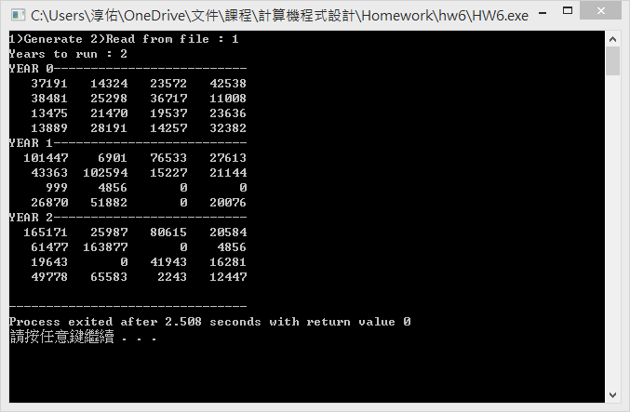

Read parameters from file :

